# **Game Design Document**

A game design document is the blueprint from which a game is to be built. As such, every single detail necessary to build the game should be addressed. The larger the team and the longer the design and development cycle, the more critical is the need. For your purpose, the intent is to capture as much as possible of your design. I want you to be clear about what the software delivers and what the design entails.

**1. Title Page**

**1.1. Game Name – Perhaps also add a subtitle or high concept sentence.**

* Dispatch Mayhem

**2. Game Overview**

**2.1. Game Concept**

The player will take on the role of a dispatcher/owner of a trucking company. They will be responsible for managing multiple types of vehicles that are in the process of delivering loads from one point to another. The player will also be able to see how their decisions affect the business they are building from a financial perspective as well. They will play the role of a business manager and shipping dispatcher.

**2.2. Genre**

Simulation / Tycoon

**2.3. Target Audience**

Business students and Simulation/Tycoon game fans.

**2.4. Game Flow Summary – How does the player move through the game. Both through framing interface and the game itself.**

The player themself does not move, but is responsible for moving vehicles around the map as well as managing several locations. They will be able to navigate around the map with a satellite view and select locations to manage them.

more detail about the choices users make, what apps they need to monitor and information they evaluate to make decisions on load.

**2.5. Look and Feel – What is the basic look and feel of the game? What is the visual style?**

* Trucks should be a 3D model when the map is zoomedin, but maybe reduced to a dot when the map is zoomed out further to get a less crowded view.

Rough sketch:

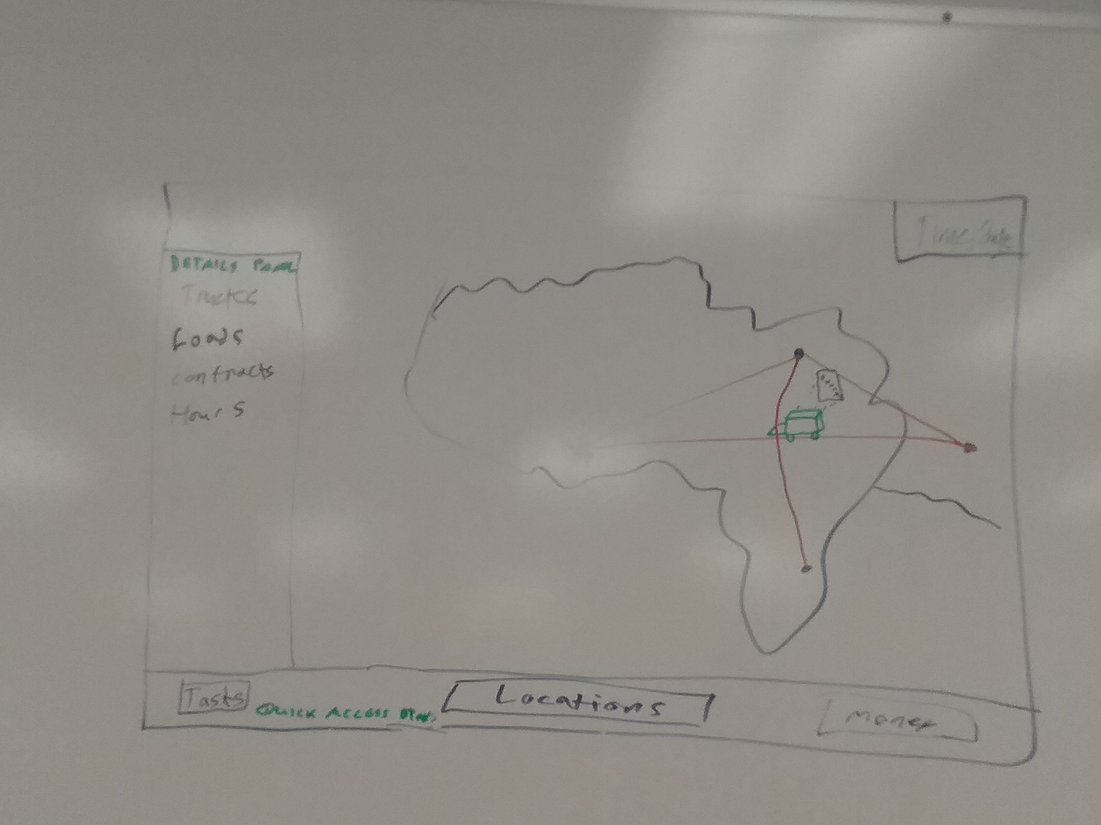

**3. Gameplay and Mechanics**

**3.1. Gameplay**

**3.1.1. Game Progression**

The player progresses by successfully picking up and delivering loads on time. Doing so will earn the player money, which they can then use to purchase new yards, trucks and trailers.

* The player should have limited access to a small number of cities.
  + Minimal goal to get familiar with the menu screen and map layout
  + Starting money, truck(s?) and yard.
* After tutorial level, the player should have a choice of their home base. (choose first yard)

Cities: Each city will have a set amount of customers that the player can choose from . City status and yard info can be accessed by clicking on the city.

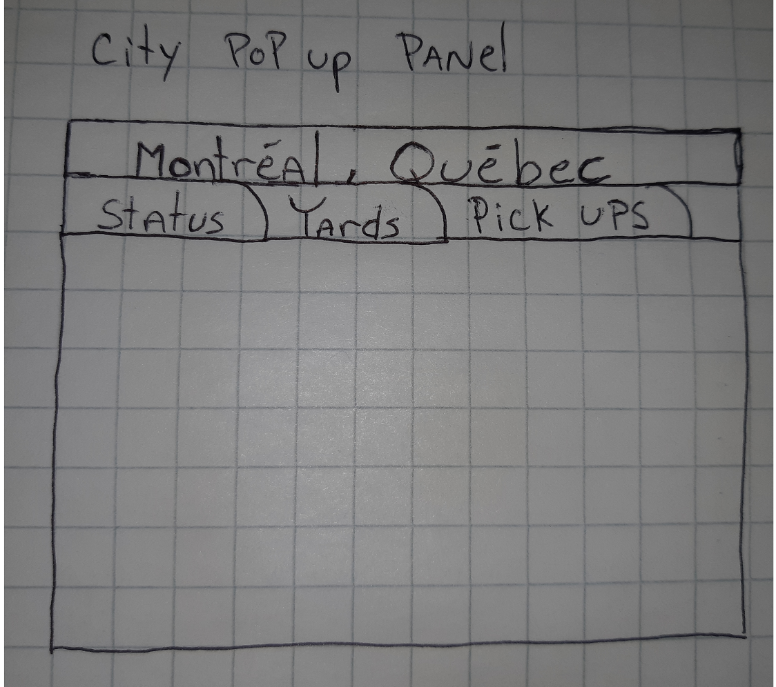

(*rough sketch)

Locations:

Britsh Columbia: Vancouver, Kelowna, Surrey

Alberta: Calgary, Edmonton

Saskatchewan: Saskatoon, Regina

Manitoba: Winnipeg, Brandon

Ontario: Cornwall, Ottawa, Toronto, Mississauga

Quebec: Montreal, Quebec city,

New Brunswick: Moncton, Saint John

Nova Scotia: Halifax

Money:

Player Starting Amount: 150,000 $

Location costs: 200,000 – 500,000 $ depending on locations.

Trucks:

Truck (used): Prices adjusted in game

Truck (new): Prices will be determined in game using real life sources.

The player will begin with an empty yard and must purchase his first (used) truck at the “Dealership” through the starting tutorial. Once a truck is purchased, the player can click the truck to see a pop up window with all the status info etc.

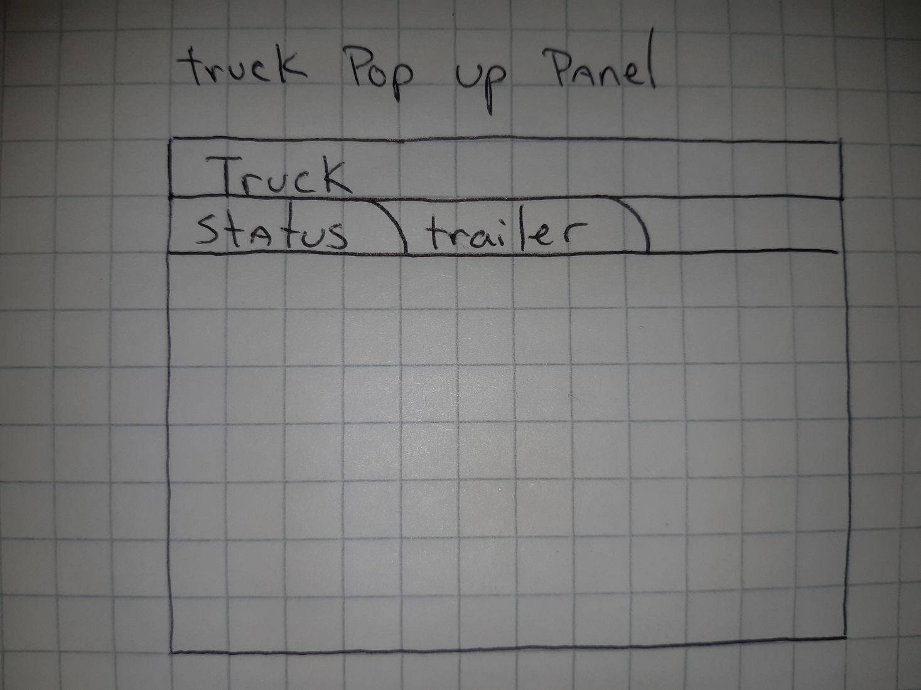

(*rough sketch)

How many different types of trucks will be included?

Trucks will have luxuries the player can pick to enhance the truck to keep their drivers happy.

Trailers: Trailers will be purchasable at the “Dealership”. Trailer status will be available by checking the trailer tab in the truck popup window by clicking on a pinned truck, or simply by clicking the empty trailer.

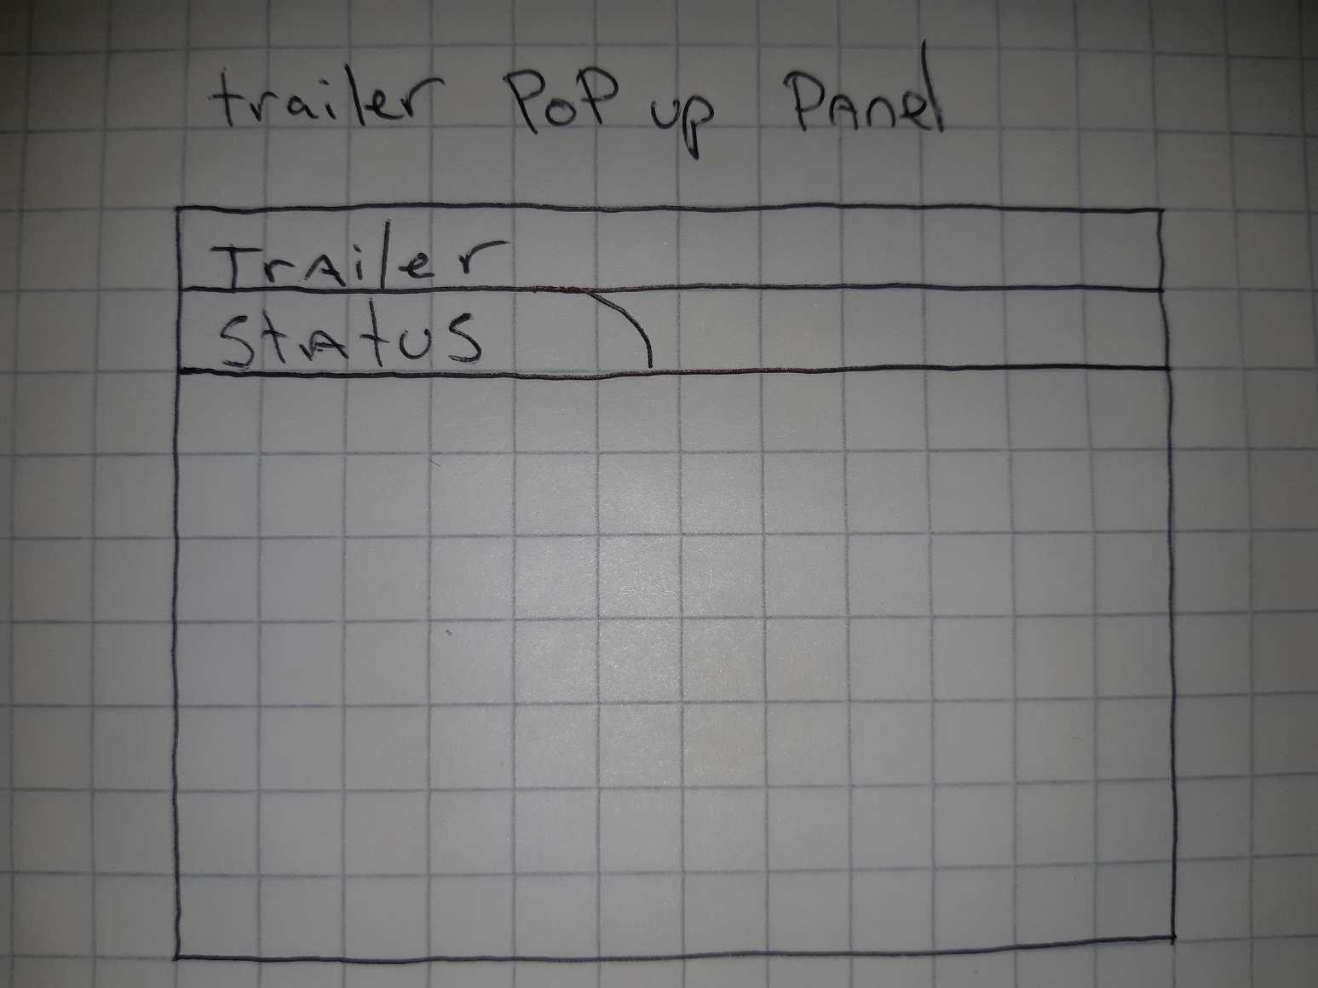

(*rough sketch)

Flatbed: Transport large machinery / equipment.

ex: tractors, backhoes, dozens, excavators, forklifts, agricultural products, manufacturing and warehousing equipment.

cost: $New 68,990

Max freight weight: 48 000 lbs

Length: 53 ft

Width: 8.5 ft

Height: 8.5 ft

Drop deck: Designed to carry haul freights that cannot be carried on a standard flatbed.

ex: lumber, cars, trucks, tanks, forklifts

cost: New $36,400 Used $10,000-15000

Max freight weight: 48,000 lbs

Length: 53 ft

Width: 8.5 ft

Height: 10 ft

Dry/Reefer van

Transport various items.

ex: pharmaceuticals and tobacco products, fine art and antiques, personal care products, perfumes, chemicals.

Dry Van cost: New $ 26,991 Used $ 8,000-12,000

Max freight weight: 42 000 lbs - 45 000 lbs

Length: 53 ft

Width: 8.2 ft

Height: 8 ft

cost:

Max freight weight: 42 000 lbs - 45 000 lbs

Length: 53 ft

Width: 8.2 ft

Height: 8 ft

Tanker: Transport liquids.

ex: liquid sugar, industrial chemicals, molasses, milk, wine, juice, water & diesel.

Chemical tanker

cost:$158,000

Max weight: 48,000 lbs

Food Grade tanker

cost: ?

Max freight weight: 48,000 lbs

Fuel Tanker

cost: $100,950

Max weight: 48,000 lbs

What is the eventual cap for all of the above where the player has completed the training involved?

When the player has obtained a total of 20 trucks with the 4 various equipment after 1 year (in-game time) the player will win

**3.1.2. Mission/challenge Structure**

Trucks needs to deliver loads with maximum efficiency and with pro-active load balancing along the way to ensure minimal space is wasted.

* deal with problems that arise to stop/delay trucks
  + log monitoring
* detail issues:
  + weather: Weather is going to be a random event happening in random areas. some weather conditions will be specific to region.
* Heavy snow: slows down trucks and closes down some parts of highways
* Rain: potentially ruin certain loads if the wrong trailer is used
* Freezing Rain: Can and will shut down roads due to dangerous conditions.
* High Winds: Strong gusty winds capable of toppling over a truck and trailer if caught out in it.
  + Truck Scales: Are a random event while a truck is on the highway. Truck check:
* Level 1: Low level check that happens 70% of the time.
* Level 2: Medium level check that happens 20% of the time
* Level 3: Very thorough check that happens 10% of the time

* + gas: The gas challenge in game will be a status attached to each truck. you will be able to hover over the truck with your mouse and view the remaining gas in that truck. The gas index will also appear in the HUD when the player clicks on the truck. Trucks will stop when empty to fuel up.
  + Loading / unload delays
    - loading : 2hrs
    - unloading : 1hr
  + traffic: traffic challenges in game will be in the form of a timer. Each city will have their own traffic delay attached to it, so when a truck enters that city, it will have to wait for that set amount of time before starting the load timer or exiting the city.
    - 3 levels city delays visually displayed by amount of building / size on map:
      * large = 2hrs
      * med = 1.5hrs
      * small = 1hr
  + Breakdown of trucks: based on reliability of vehicle,
    - used trucks, the older the vehicle the more of a delay.
    - cost to repair is semi random within a range
    - What is the range?
      * 500$ - > truck cost entirely.
      * List of breakdowns, cost to repair, delay time.
  + Weekly Summary
    - expected money at specific time into the game
    - 3 star rating for the week

**3.1.3. Puzzle Structure**

Player will need to manage events such as fines, weather, breakdowns, etc.

dealing with issues (see 3.1.2)

**3.1.4. Objectives – What are the objectives of the game?**

Make money from proper load management and delivery to increase profit and profitability. Acquire more equipment and warehouse space.

cover all locations and purchase all equipment!

RETIREMENT!!!

* Game should not have a “win” condition. Try to get the highest score possible in a set amount of time without meeting any of the “lose” conditions.

**3.1.5. Play Flow – How does the game flow for the game player**

Game will play in real time, but the player will have the ability to manipulate the flow of time. Slower, faster, pause, etc.

player process managing the funds to increase loads on the go, but may have strikes for mistakes.

**3.2. Mechanics – What are the rules to the game, both implicit and explicit. This is the model of the universe that the game works under. Think of it as a simulation of a world, how do all the pieces interact? This actually can be a very large section.**

**3.2.1. Physics – How does the physical universe work?**

TBD.

**3.2.2. Movement in the game**

Vehicles will be chosen and destination will be selected and confirmed by the player. Vehicles will navigate to objectives on paths that may change according to populating loads on the way.

point and click on destinations.

menu systems details here.

**3.2.3. Objects – how to pick them up and move them**

Objects will be picked up and dropped off automatically once selected along with assigned vehicle for delivery and delivery location.

**3.2.4. Actions, including whatever switches and buttons are used, interacting with objects, and what means of communication are used**

The majority of gameplay will consist of actions via the User Interface.

**3.2.5. Economy – What is the economy of the game? How does it work?**

Each load will generate a certain amount of income.

**3.2.6. Screenflow -- A graphical description of how each screen is related to every other and a description of the purpose of each screen.**

The UI will ideally have quick / easy access to the most important information. We do want the user to have to go somewhat into menu systems to find information like log book hours.

**3.3. Game Options – What are the options and how do they affect gameplay and mechanics?**

TBD.

**3.4. Replaying and Saving**

A system to save the current state of everything should be implemented so the player can save and reload where they left off. TBD at production level.

**3.5. Cheats and Easter Eggs**

TBD. Less important.

**4. Story, Setting and Character**

**4.1. Story and Narrative – Includes back story, plot elements, game progression, and cut scenes. Cut scenes descriptions include the actors, the setting, and the storyboard or script**.

This is a simulation/tycoon game, so the story will not be very detailed if there even is one. Narrative to consider may come in the form of a Tutorial system.

**4.2. Game World**

**4.2.1. General look and feel of world**

[Insert Sketch here]

**4.2.2. Areas, including the general description and physical characteristics as well as how it relates to the rest of the world (what levels use it, how it connects to other areas)**

Cities will be represented by nodes that are interconnected in a web along major highways.

**4.3. Characters. Each character should include the backstory, personality, appearance, animations, abilities, relevance to the story and relationship to other characters**

Characters will be different vehicles and drivers

*SG*: (possibility to implement random personalities that can affect events).

**5. Levels**

**5.1. Levels. Each level should include a synopsis, the required introductory material (and how it is provided), the objectives, and the details of what happens in the level. Depending on the game, this may include the physical description of the map, the critical path that the player needs to take, and what encounters are important or incidental.**

Levels will be distinguished by how much real estate has been obtained on the map. As you progress, you can unlock more vehicle types, storage facilities, etc.

**5.2. Training Level**

* No Tutorial “Level”. Tutorials should just arise as new features appear in game.
* embedded into the game as new features are required or introduced.

**6. Interface**

**6.1. Visual System. If you have a HUD, what is on it? What menus are you displaying? What is the camera model?**

HUD will have some basic statistics along with pull-out menus to view key data.

- money

- time / time controls

- notifications

- loads to be picked up

- trucks with trailer numbers

**6.2. Control System – How does the game player control the game? What are the specific commands?**

Game will be controlled with a keyboard and mouse.

**6.3. Audio, music, sound effects**

TBD.

**6.4. Help System**

Pop-up hints on key functions.

**7. Artificial Intelligence**

**7.1. Opponent and Enemy AI – The active opponent that plays against the game player and therefore requires strategic decision making**

Enemy AI will consist of events that occur that incur additional costs for deliveries, such as weather, breakdowns, fines, etc.

**7.2. Non-combat and Friendly Characters**

Checkpoint NPCs, Other Companies, Independent Truckers.

**7.3. Support AI -- Player and Collision Detection, Pathfinding**

AI will control the pathing for vehicles between locations as well as weather events and other things that may hinder the trucks.

**8. Technical**

**8.1. Target Hardware**

PC, Android, iOS(future).

**8.2. Development hardware and software, including Game Engine**

Developing in Unity, Visual Studio, possibly Photoshop and Blender.

**8.3. Network requirements**

Wifi or LAN Connection.

**9.**  **Game Art – Key assets, how they are being developed. Intended style.**

In 2D: The UI, Map, as well as buttons.

In 3D: Trucks, Trailers, and Waypoints for Cities.

(+ asset pictures to come)